PROJECT REPORTING

BidWin Project 2014/2015

Emanuele La Malfa emanuele.lamalfa@mail.polimi.it
Davide Malvestiti davide.malvestiti@mail.polimi.it

1.FUNCTION POINTS ANALYSIS

Internal Logic Files
We have a database composed by 7 tables: Users, Auction, Objects, Bid, Notifications, Group and User_groups and Participation. All of them - but Group which is indeed very simple - can be considered of medium complexity.
Total 6 average, 1 low => 6*10 + 7 = 67

External Interfaces
No external interfaces

External Inquiries
No internal inquiries

External Inputs
User inputs include Registration, Login/Logout, Search Engine, Create Objects, Create Auctions, Recharge pocket:
Total: 5 Simple, 1 High => 6 + 3*5 = 21

External Outputs
Bids Information, Auctions Infromation - history + current state -, Users Infromation, notifications
4 Low => 4*5 = 20

2.Count and comparison with actual data

Total count: 108
Unadjusted SLOC count, using J2EE as language: 108 * 46 = 4968
Comparison with actual SLOC count (Obtained with CLOC, on the sources folder, excluding all non programming languages)
6213 Java SLOC
We have to subtract from that count about 800 lines of code which belong to the crud used in the admin session (partially created automatically)
So the actual count is
5413 Java SLOC

Just for completeness we add the result of the command cloc - which also includes XML and SQL in the total count-.
cloc-1.64.exe /bidwin/

100 files
196 text files.
classified 196 files
Duplicate file check 196 files (138 known unique)
Unique: 100 files
138 unique files.
Counting: 100
145 files ignored.

http://cloc.sourceforge.net v 1.64 T=3.06 s (38.2 files/s, 3730.9 lines/s)
-----------------------------------------------------------------------------------
Language files blank comment code
-----------------------------------------------------------------------------------
Java 54 804 1916 3720
JavaServer Faces 48 202 0 2493
XML 11 9 111 1649
SQL 1 48 75 222
CSS 1 10 0 72
Visualforce Component 1 0 0 28
Ant 1 12 54 5
-----------------------------------------------------------------------------------
SUM: 117 1085 2156 8189
-----------------------------------------------------------------------------------

3.COCOMO2 Analysis

We will derive the required effort using the COCOMO2 post architecture model, using the actual source line count.
Master formula:
PM = 2.94 * [Size]^E * product(effort multipliers)
Where
E = 0.91 + 0.01 * sum(scale factors)
Size = 3KSLOC (considering 0 adapted SLOC, and 0 breakage factor due to requirements changes)
All terms regarding adapted sources have been set to zero because we’re developing a product from scratch.
Scale and Cost drivers
According to the Cocomo specifications, for each of the cost and scale drivers, a value between very low and very high is chosen. Each value is mapped to a weight (that can be found on the tables in the linked manual) and computed in the formulas above.
To perform these calculation conveniently we used an online calculator. In the screenshot below, the values we chosen for every driver can be seen, as well as the result of the calculation.
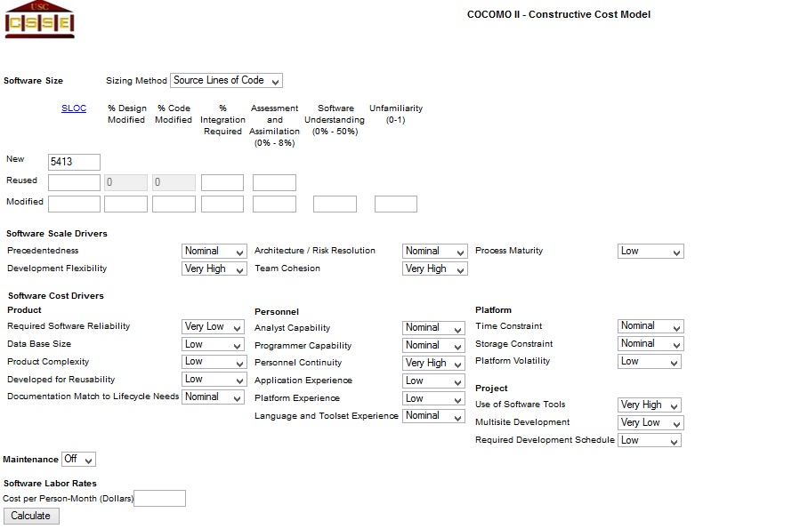

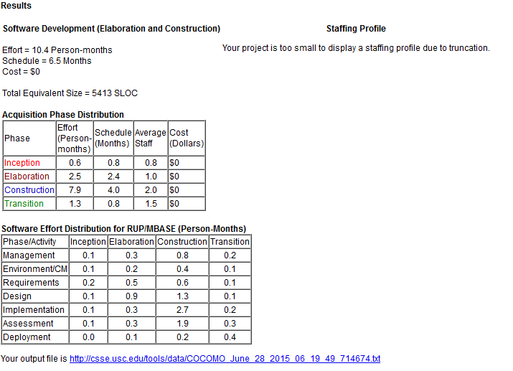

4.CONCLUSIONS
We kept count of the amount of time each members spent on the project.
Here’s the result:
RASD: about 25 hours each
DD: about 25 hours each
Implementation: about 80 hours each
Acceptance: about 7 hours each
The result is 274 hours of work.
Please note that the project is a prototype, and since it was developed for scholastic purposes, the difference between expected and actual hours is justified.

5.REFERENCE

COCOMO2.2000 manual: http://csse.usc.edu/csse/research/COCOMOII/cocomo2000.0/CII_modelman2000.0.pdf

FP->KSLOC:
http://www.qsm.com/resources/function-point-languages-table

